Greater Manchester Bereavement Service

Social Media Pack

Introduction
This pack includes content for social media channels to be used to raise awareness of Greater Manchester Bereavement Service to encourage people who are bereaved to seek support from the service if needed. The service is also for professionals and those worried about someone else who is bereaved.
Pack contents include:
- Suggested social media posts signposting people to www.greater-manchester-bereavement-service.org.uk
- Graphics – to be supplied separately from this Word doc

Contact
- Ellen Petty: ellen.petty@greatermanchester-ca.gov.uk
Social media posts
Post | Media
Greater Manchester Bereavement Service can help find support for anyone in Greater Manchester that is bereaved or affected by a death.  No one needs to feel alone as they deal with their grief.  Find out more www.greater-manchester-bereavement-service.org.uk | 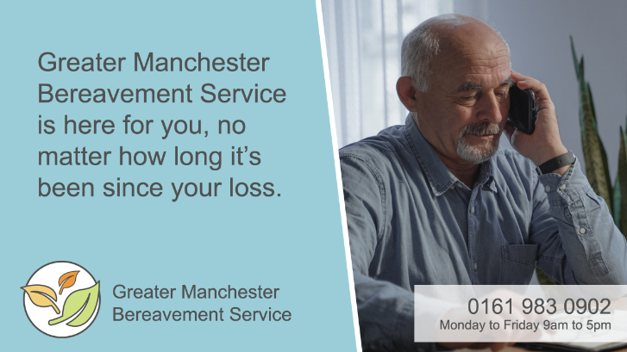  GMBS 1
If you’re grieving and need support, call the Greater Manchester Bereavement Service.  A friendly bereavement practitioner will listen and help find the right support for you.  Find out more www.greater-manchester-bereavement-service.org.uk | 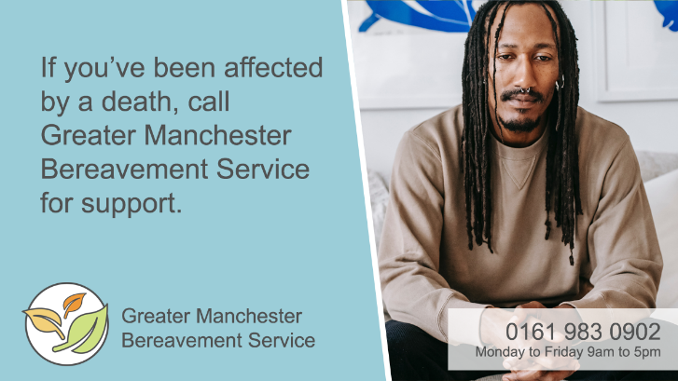  GMBS 2
Grief affects us all differently but whatever you’re going through Greater Manchester Bereavement Service is here to help you get the support you need.  Find out more www.greater-manchester-bereavement-service.org.uk | 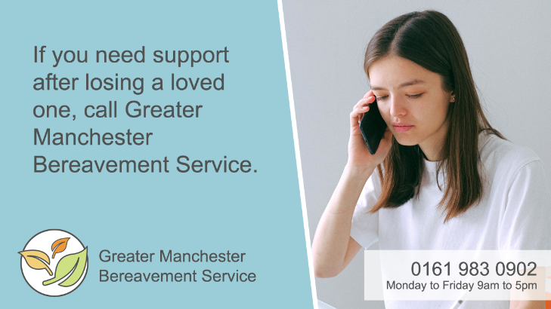  GMBS 3
No one needs to feel alone as they come to terms with their bereavement.  Greater Manchester Bereavement Service is here for you, no matter how long it’s been since your loss or the cause of death.  Find out more www.greater-manchester-bereavement-service.org.uk | 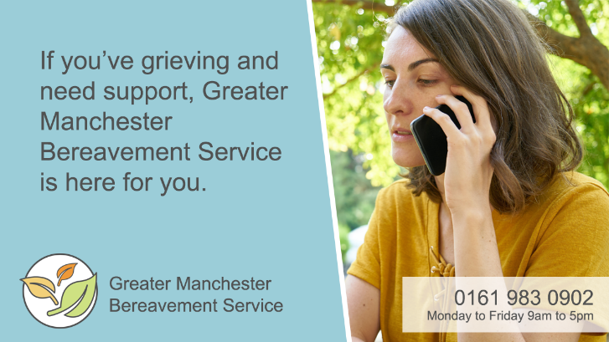  GMBS 4
Any bereavement is hard but losing someone to suicide brings different challenges.  That’s why Greater Manchester Bereavement Service have dedicated suicide bereavement practitioners to support you through your grief.  Find out more www.greater-manchester-bereavement-service.org.uk | 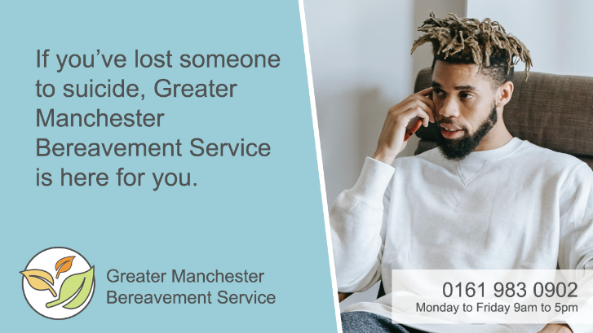  GMBS 5
Dealing with the loss of a loved one is hard.  Look after yourself, give yourself permission to grieve and seek support if you need it.  Get help today www.greater-manchester-bereavement-service.org.uk | 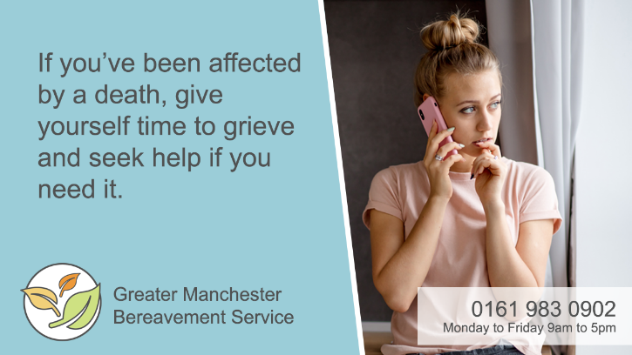  GMBS 6
It’s important to take care of yourself following a bereavement. Lots of people find it helpful to talk to others about the person who has died and their memories of them.  Talk to a bereavement practitioner today www.greater-manchester-bereavement-service.org.uk | 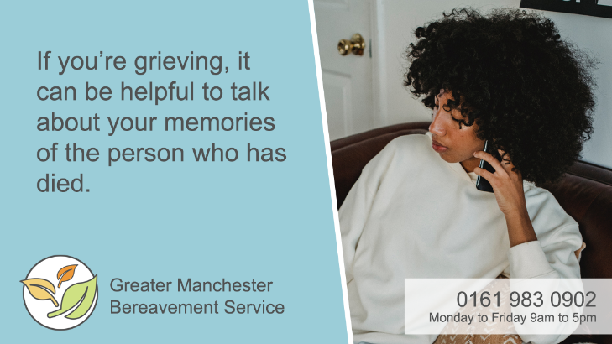  GMBS 7
Losing someone to suicide can leave you with a whole range of emotions but you do not have to deal with difficult feelings alone.  Talk to a suicide bereavement practitioner who can help support you through your grief.  Get support today www.greater-manchester-bereavement-service.org.uk | 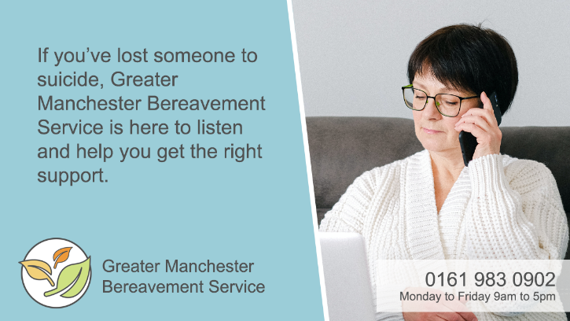  GMBS 8
If you’ve been affected by a death and need support, Greater Manchester Bereavement Service is here for you.  Get support today www.greater-manchester-bereavement-service.org.uk | 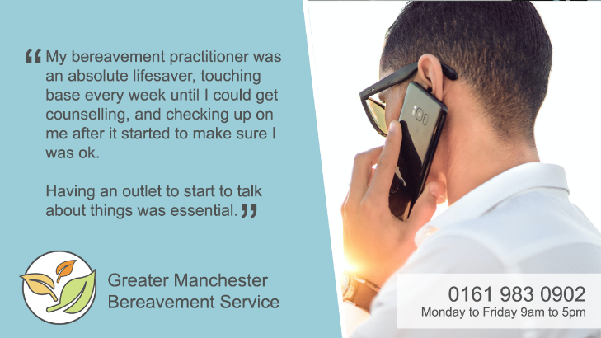  GMBS Quote 1
Worried about someone who’s bereaved?  Greater Manchester Bereavement Service also provides advice for those who want to know how to support someone who is grieving.  Find out more www.greater-manchester-bereavement-service.org.uk | 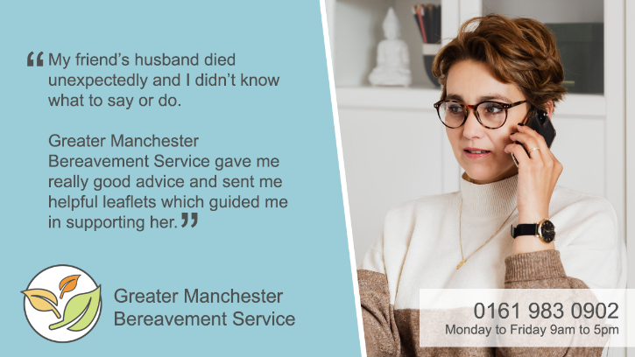  GMBS Quote 2

